# Shree Ram World School

**III-V Activity Planner-October2023**

ATTRACTIONS OF THE MONTH

1. PAINT THY IMAGINATION

2. KHANSAMA (FLAMELESS COOKING)

3. JOY OF GIVING

4. LOCAL TO GLOBAL

5. FINE ARTS WORKSHOP

SATURDAY

FRIDAY

THURSDAY

WEDNESDAY

TUESDAY

7

5

2

6

4

3

MONDAY

**GANDHI JAYANTI**

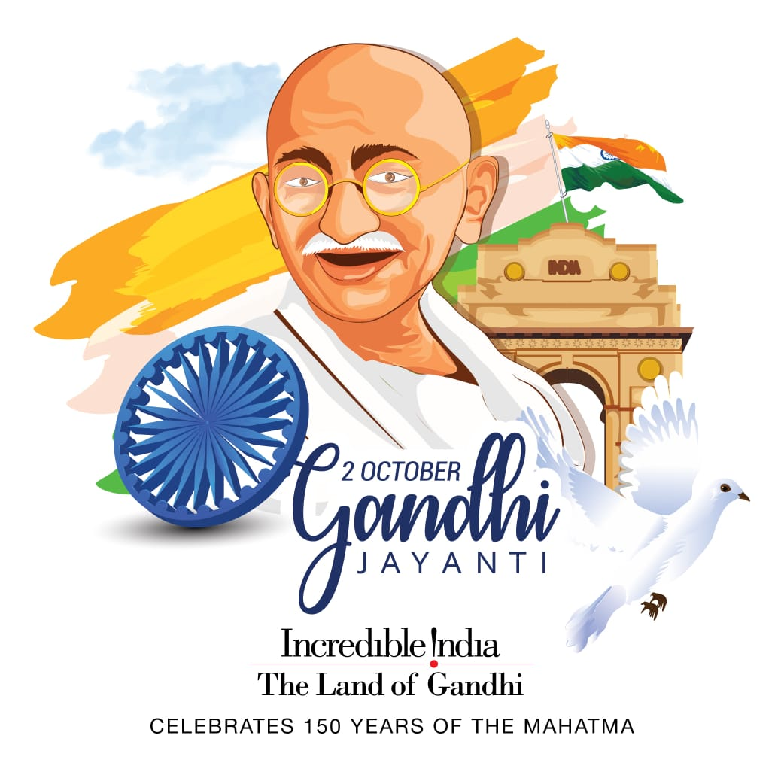





**PREPARATORY**

**LEAVE**

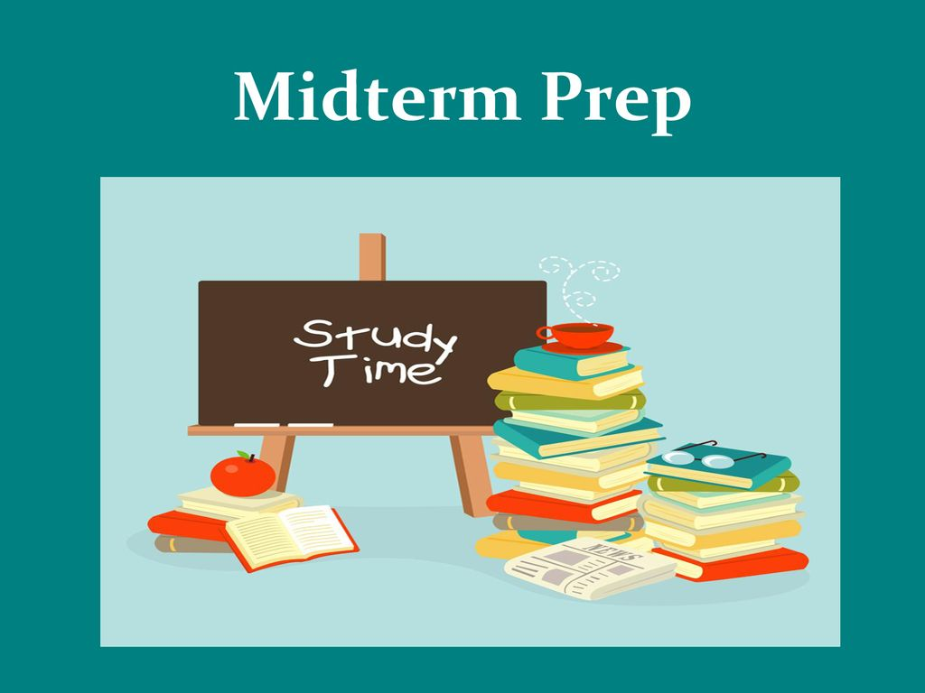

**PREPARATORY**

**LEAVE**



**PREPARATORY**

**LEAVE**





**NATIONAL UNITY DAY**

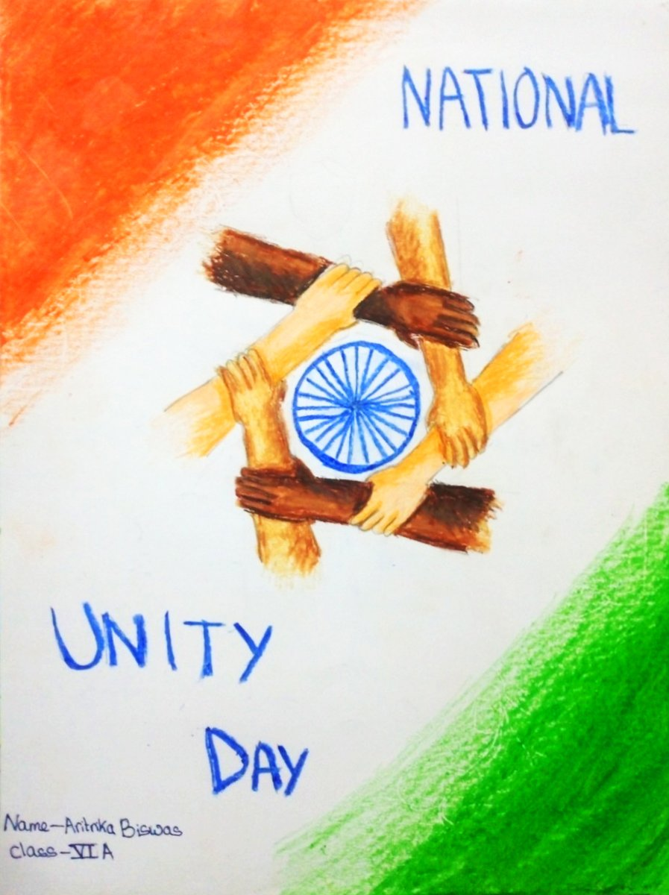

31

**PAINT THY IMAGINATION**



**VALMIKI JAYANTI**



28

**LOCAL TO GLOBAL**



**DUSSEHRA**



**MAHA NAVMI**



23

**POLICE COMMEMORATION DAY**



**KHANSAMA (FLAMELESS COOKING)**



**WASTE MANAGEMENT**

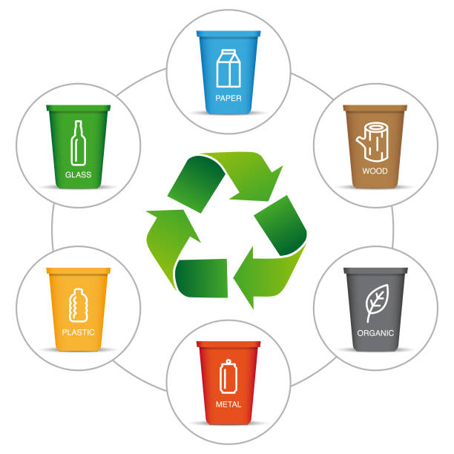



**NEWSPAPER READING**



**HEATS FOR SPORTS DAY RESUME**



**REGULAR CLASSES RESUMES**



20

14

13

12

11

10

27

**CLUB**

**CLASS III**



**CLUB**

**CLASS IV**



**CLUB**

**CLASS V**



**CLUB**

**CLASS III**



**PTM**



**CLUB**

**CLASS IV**



17



30

24

26

25

21

19

18

16

9